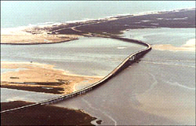
Replacement of the Herbert C. Bonner Bridge (Bridge No. 11) on NC 12 over Oregon Inlet

Citizens Informational Workshop
June 26, 2003

Rodanthe Waves Salvo Community Center & Cape Hatteras Secondary School

Welcome.

Welcome to the North Carolina Department of Transportation’s (NCDOT’s) Citizens Informational Workshop for the proposed replacement of the Herbert C. Bonner Bridge. The NCDOT plans to prepare an Environmental Impact Statement (EIS) for the replacement of the existing bridge on NC 12 over Oregon Inlet. The purpose of the proposed project is to replace the existing bridge prior to the end of its reasonable service life so that the need for convenient daily travel and emergency access across the Oregon Inlet can continue to be met. The EIS will evaluate several alternatives.

Tonight's workshop has three purposes.

- To introduce the EIS study.
- To introduce two potential replacement corridors and their characteristics.
- To discuss concerns, receive comments, and answer questions on the corridors and any other aspect of the study.

The agenda tonight is informal.

We have brought several display boards that:

- Illustrate corridor alternatives for the proposed Bonner Bridge Replacement project;
- Compare the two corridor alternatives still under consideration at this time;
- Display many of the issues that will be evaluated in the environmental study;
- Show the schedule for the proposed project; and
- Present the ways the public can be involved in the project study.

Representatives from the study team are here and can be found at the display boards. They are ready to discuss your concerns, receive comments, and answer any questions you may have regarding the project.

We welcome comments on any aspect of the study.

We would particularly like to hear your thoughts on:

- The characteristics of the study area and their relative importance to study decision-making; and
- The types of information you want to know so that we can keep you informed.
Comments we receive, either in person tonight or by mail, will be considered during the course of the study. If you want to give us your comments in writing, the attached form is provided for your convenience.

Your comments are welcome throughout the study.

We are looking forward to your continued participation. You may call or write the study team with concerns, comments or questions throughout the study. Call the project’s toll-free information line

➔1-866-803-0529⬅

between 8 a.m. and 5 p.m. Monday through Friday. You can leave your recorded comment or question and someone will call you back. Or you can connect to an operator who can transfer your call to a member of the study team. A voice mail service answers the information line during non-business hours and you can leave a recorded message. You may send written comments to:

Mr. John Page, AICP, CEP
Parsons Brinckerhoff Quade & Douglas, Inc.
909 Aviation Parkway, Suite 1500
Morrisville, NC 27560

If you would like to write the North Carolina Department of Transportation, address your letters to:

Ms. Jennifer Harris, PE
North Carolina Department of Transportation
Project Development and Environmental Analysis Branch
1548 Mail Service Center
Raleigh, NC 27699-1548

Copies of the first issue of the Bonner Bridge Update newsletter are available here tonight. If you would like to be added to our newsletter mailing list, please check the appropriate box on the attached comment sheet. You can leave the comment form at the sign-in table or mail it to the address at the bottom of the form.

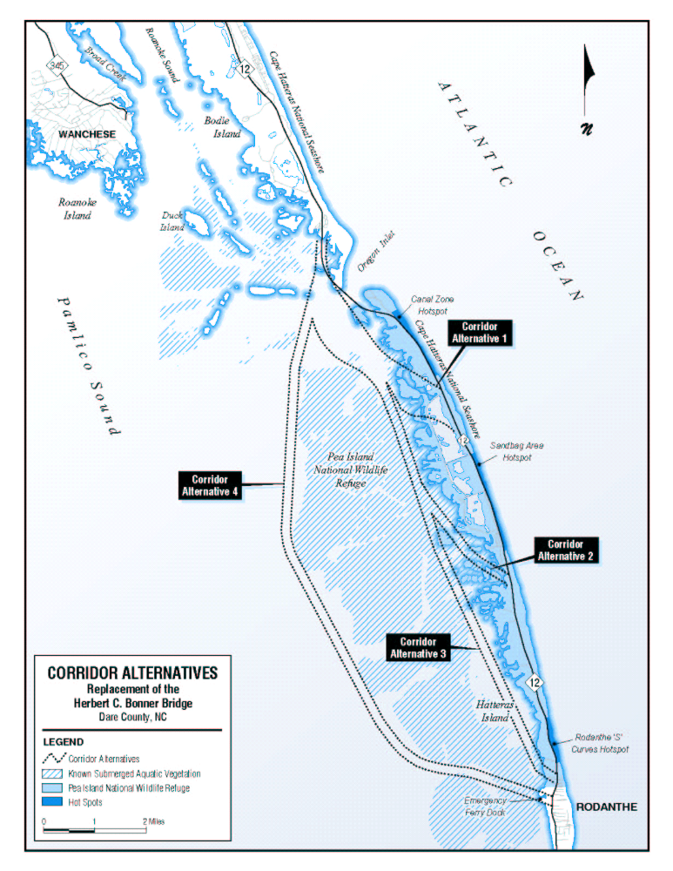
SUBMERGED AQUATIC VEGETATION STUDY
NEAR BONNER BRIDGE

The NC Department of Transportation (NCDOT) is in the process of performing a Submerged Aquatic Vegetation (SAV) study in Pamlico Sound for the construction of a replacement bridge over Oregon Inlet. To assist with this study, NCDOT has constructed 24, 10’x10’ platforms that will be used by the NCDOT Photogrammetry Unit to control aerial photography. The aerial photography will be used to accurately map the locations of submerged aquatic vegetation (sea grass).

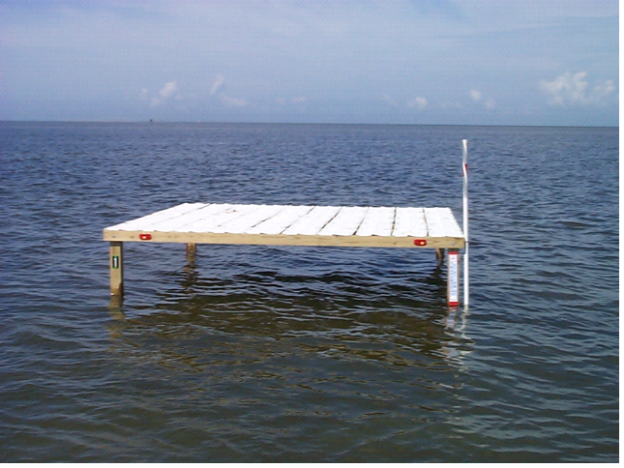
These platforms are made of treated 2”x4”s attached to 4”x4” posts extending 3’ to 4’ above the water with white vinyl nailed to the top. An amber flashing photocell light will be attached to the top of each platform. The light will flash every 4 seconds. Red and yellow alternating reflectors will be attached to the lights.

At the conclusion of this study, these platforms will be removed. The time frame to complete this study could be anywhere from 6 months to one year depending on the weather.
Example of a platform without the light attached.

The approximate locations of these platforms are as follows:

Platform No. | Latitude | Longitude | Platform No. | Latitude | Longitude
1 | N 35^33’08.4” | W 75^31’55.8” | 13 | N 35^42’30.6” | W 75^34’22.4”
2 | N 35^35’15.2” | W 75^33’01.8” | 14 | N 35^44’39.4” | W 75^35’36.2”
3 | N 35^37’18.3” | W 75^34’11.4” | 15 | N 35^46’50.1” | W 75^36’44.8”
4 | N 35^39’30.7” | W 75^35’23.2” | 16 | N 35^49’09.8” | W 75^37’43.0”
5 | N 35^41’41.1” | W 75^36’34.1” | 17 | on land | on land
6 | N 35^43’51.5” | W 75^37’45.8” | 18 | N 35^36’47.2” | W 75^28’37.4”
7 | N 35^46’01.9” | W 75^38’57.1” | 19 | N 35^38’57.5” | W 75^29’47.9”
8 | N 35^48’12.4” | W 75^40’07.8” | 20 | N 35^41’07.8” | W 75^30’58.2”
9 | N 35^33’57.1” | W 75^29’43.8” | 21 | N 35^43’18.1” | W 75^32’09.1”
10 | N 35^35’45.7” | W 75^30’51.3” | 22 | N 35^45’28.4” | W 75^33’20.8”
11 | N 35^38’08.9” | W 75^32’00.4” | 23 | N 35^47’43.2” | W 75^34’26.2”
12 | N 35^40’18.9” | W 75^33’10.2” | 24 | N 35^49’47.3” | W 75^35’43.3”

For further information regarding the SAV study or these platforms please contact T.K.Wheeler, PE, PLS @ 252-514-4784 or Parks Icenhour, PE, PLS @ 919-662-4616.
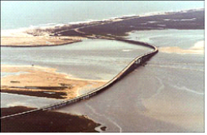
Replacement of the Herbert C. Bonner Bridge (Bridge No. 11) on NC 12 over Oregon Inlet

Citizens Informational Workshop
June 26, 2003
Rodanthe Waves Salvo Community Center & Cape Hatteras Secondary School

Name:
Address: |  |  |  |  | Apt./Suite No:
City: |  |  |  |  | State: |  | Zip:
Telephone:
Representing:
 | Check if you want to be added to the mailing list and receive future issues of the newsletter
Comments:

Which meeting location did you attend? Rodanthe _____ or Buxton _____

Please leave your completed comment form at the sign-in table or mail it to:
Mr. John Page, AICP, CEP
Parsons Brinckerhoff Quade & Douglas, Inc.
909 Aviation Parkway, Suite 1500
Morrisville, NC 27560

